Computer Architecture Course: IT089IU
International University – VNU HCM Date: March 2021
Dr. Le Hai Duong & Dr. Ly Tu Nga Time: 6 hours

Full name:
Student ID:
Laboratory Session 9
MIPS for MSP430
Objectives
After completing this experiment, you will be able to:
-How to use Code Composer Studio for implementation (Link).
-How to understand, explain, and analysis the sample codes in reality.
Activities
-Demo Kit MSP430 (devices are supported by Instructor)
Materials Needed
-Read carefully: Assemblers_Linkers_and_the_SPIM_simulator.pdf, QtSpim-Tutorial.pdf, MIPS_ short.pdf, msp430g2553_doc2.pdf, MSP_doc1.pdf

I. Introduction to CCS (70Points)
+Download and install the newest version of Code Composer Studio from:
https://software-dl.ti.com/ccs/esd/documents/ccs_downloads.html
+ Create the new project by Alt+Shift+N
+ In Target, type msp430g2553 and in project name please type yourfullname_lab1, select Empty Project (with main.c)
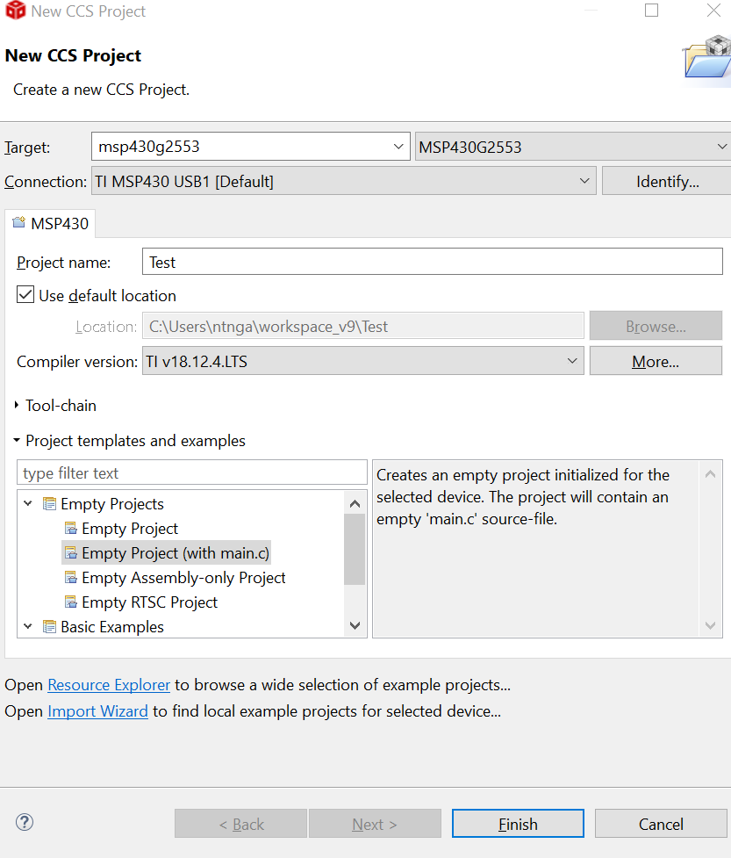
+ In main.c, type the sample code of Table 1
Table 1. control LED under controlled Loop in MSP430
No. | Test (Sample Code) | Comments/Results/Functions
1.  2  3  4  5  6  7  8  9  10  11  12  13  14  15  16  17  18  19  20 | #include <msp430.h>  #define LED1 BIT0  #define LED2 BIT6  #define DELAYLOOPS 32000  /* main.c */  void main(void)  {  int LoopCtr;  WDTCTL = WDTPW | WDTHOLD;  P1DIR =LED1|LED2;  P1OUT =LED1|LED2;  while(1){  for(LoopCtr=0;LoopCtr<DELAYLOOPS;++LoopCtr)  {  }  P1OUT ^=LED1|LED2;  }  } | Macro LED1 (assigned P1.0 or BIT0)  Macro LED2 (assigned P1.6 or BIT6)  Stop watchdog timer.  Setup LED1 and LED2 to direction output and turn on  empty delay loop  toggle LEDs
+ Click build “debug” and observe the console window: Build finished

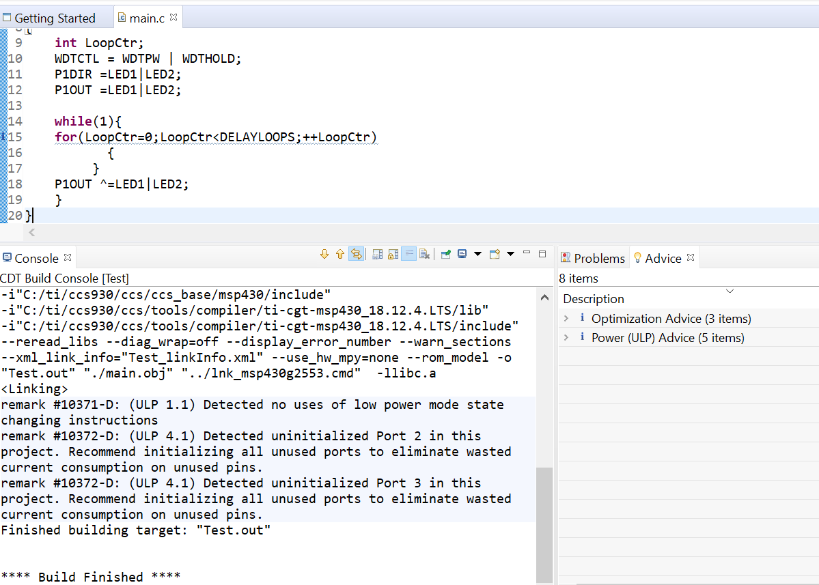

+ Click Run Debug and select Run in background
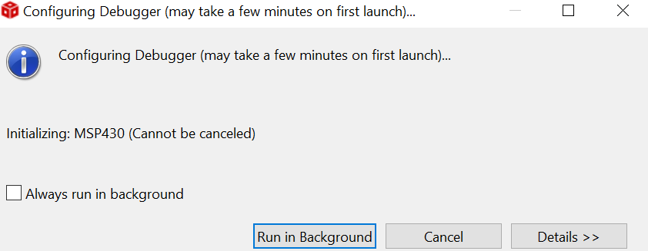

Step 1: Evaluation memory allocation: click View> Memory Allocation
Fill in the percentage of RAM allocation: ______________ and files:
Fill in the percentage of FLASH allocation: ______________ and files:
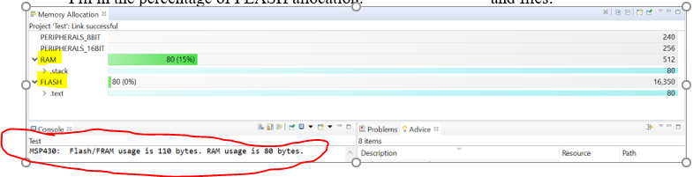

Step 2: Not run, click lnk_msp430g2253.cmd to fill in these answers.
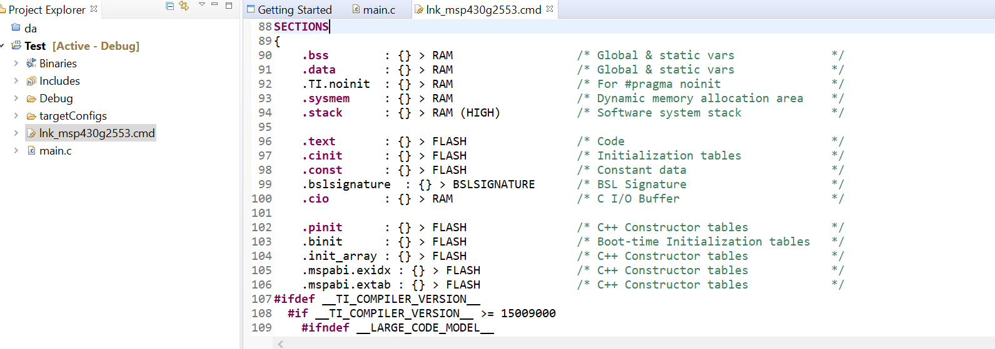
Summary some sentences of SECTIONS (Specify the sections allocation into memory: lines 88-109
Step 3: open test.map and fill in these addresses following:
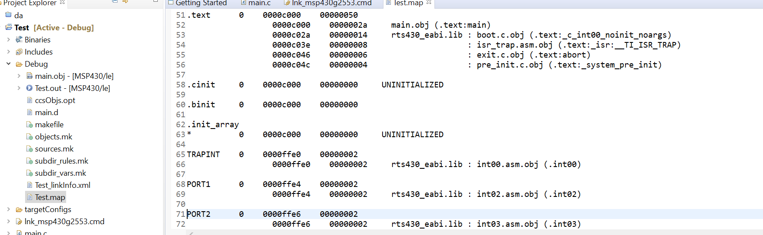
address: __________
In Section Allocation MAP:
-text:_____________________
-stack: ______________________
-WDT: _____________________
-Port 1: _____________________
-Reset: ___________________
Memory Configuration: INT02: __________________
Global symbols: sorted alphabetically by Name:
-P1IN:___________
-P1OUT: ____________
- main:_____________
-WDTCL:___________
-LoopCtr: __________
How many symbols? __________
Step 4: The Value of registers:
P1IN: before __________ and after ___________
P1OUT: before __________ and after ___________
LoopCtr: before __________ and after ___________
Hint: you can use Expression or open the Core Registers tab (Port_1_2) to find the solution
Explain the values of P1IN and P1OUT registers in Port_1_2: ________________________________________________________________________________________________________________________________________________
Step 5: When running and pausing, observe the Core Registers in Registers tab and please write down comments about the transition of these registers in there.
________________________________________________________________________________________________________________________________________________________________________________________________________________________________________________________________________________________________
Step 6: how to use breakpoint in CCS : Alt+Shift+Q,B
________________________________________________________________________________________________________________________________________________
Step 7: When running and pausing, click View and open Dis-assembly window, write down these instructions of sample code:
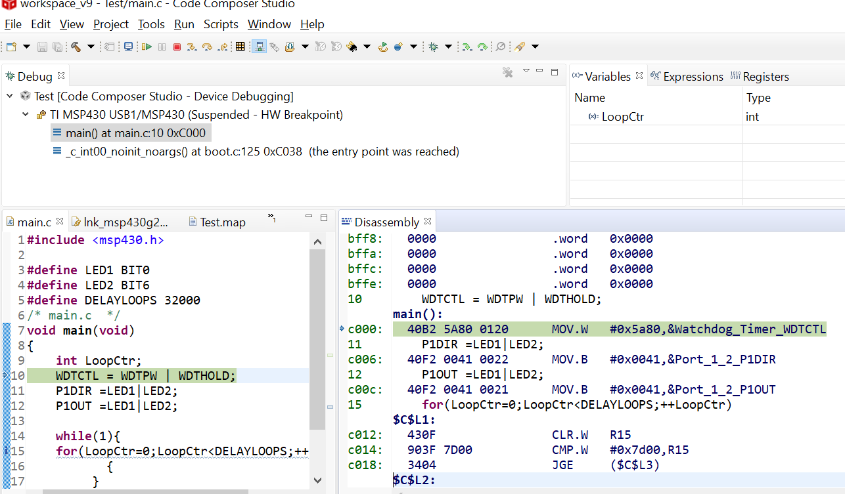

Step 8: Based on the step 7, please explain the process of sample code under Computer Architecture structure

Step 9: Change the time DELAYLOOPS to the period of LED1 is twice that of LED2.
Your code is changed (after successfully checked)
Explain the registers, address, memory, etc which will be changed to fulfill the new condition. ______________________________________________________________________________________________________________________________________________________________________________________________________________________________________________________

II. Control LED via pushing button in MSP430 (30pts)
Given a sample code to control LED via pushing button in MSP430 as follows
No. | Sample codes | Comments/Results/Functions
1.  2  3  4  5  6  7  8  9  10  11  12  13  14  15  16  17  18  19  20  21  22  23  24  25  26  27  28  29 | #include <msp430.h>  #define Red BIT0  #define Green BIT6  #define Button BIT3  void main(void) {  WDTCTL = WDTPW | WDTHOLD;  P1OUT |= Red;  P1OUT &= ~Green;  P1DIR |= Red +Green;  P1DIR &= ~Button;  P1REN |= Button;  P1OUT |= Button;  while(1)  {  if ((P1IN & Button)!= Button)  {  while ((P1IN & Button)!= Button)  {  }  P1OUT ^= Red + Green;  }  }  }

Step 1: build the sample code in CCS, check the errors.
Step 2: Not run, the values of these registers (PORT_1_2):
P1OUT:
P1IN:
P1DIR:
P1REN:
P1IFG:
Step 3: Run, observe and collect the values of these registers in case of
 | Red LED On | Green LED On
P1OUT
P1IN
P1DIR
P1REN
P1IFG
Comment and explain the Table above: ________________________________________________________________________________________________________________________________________________ _______________________________________________________________________________________________________________________________________________

When running and pausing, click View and open Disassenbly window, write down these instructions of sample code:
No. | C code | MIPS code
1.
2
3
4
5
6
7
8
9
10
11
12
13
14
15
16
17
18
19
20
21
22
23
24
25
26
27
28
29

Based on the Table above, please explain the process of sample code under if-then else conditional statements:
________________________________________________________________________ _______________________________________________________________________________________________________________________________________________________________________________________________________________________ _______________________________________________________________________________________________________________________________________________

Problem 1: modify the sample code in order to when pressing the button two LEDs turn on and vice versa.
Your code:

Reference:
- https://en.wikibooks.org/wiki/MIPS_Assembly/Pseudoinstructions
- https://courses.missouristate.edu/KenVollmar/MARS/Help/SyscallHelp.html
- https://www.assemblylanguagetuts.com/mips-assembly-programming-tutorials/#MIPS_Data_Types
- https://en.wikibooks.org/wiki/MIPS_Assembly/Arithmetic_Instructions
- https://gab.wallawalla.edu/~curt.nelson/cptr280/lecture/mips%20arithmetic%20instructions.pdf

